**National University of Computer and Emerging Sciences**



In Lab 6

“Nested Queries”

Database Systems

Spring 2024

Department of Computer Science

FAST-NU, Lahore, Pakistan

**Exercise:**

For this exercise use the following schema, the script to create this schema and populate data is given in ATM.SQL file

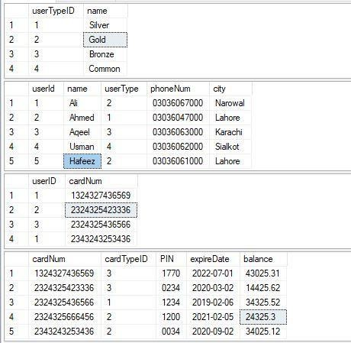

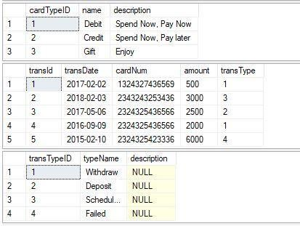

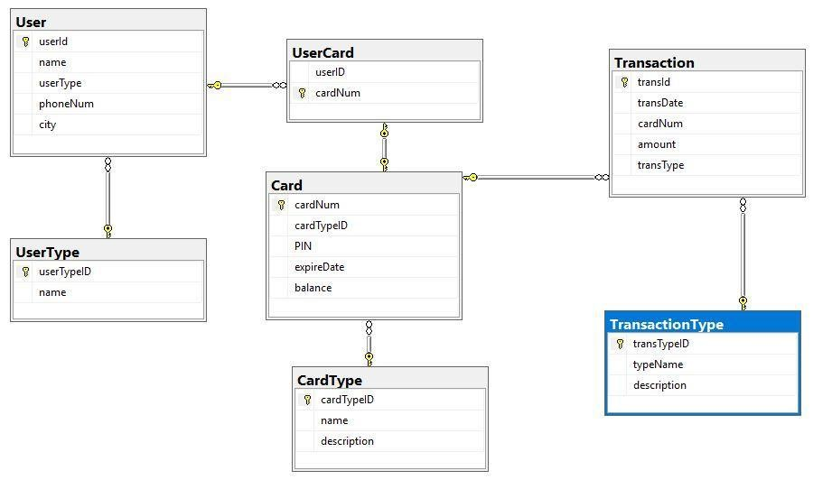

1. List the card numbers of those cards that are not used for transaction. (Hint: IN)
2. List the name of the user who has maximum balance in his/her card (One person can have more than 1 card, check cards individually for max balance).
3. List the **user** names with their **UserType** name without using join.
4. List all the **users** made **failed transactions**.
5. List the **user** who has made maximum **transactions**.
6. List the **userTypes** of users who have **credit** cards, in the **descending** order according to the ***count of cards***.
7. List the cardTypes along with the count of users. (In descending order according to count of users).
8. Give the **user** who has second maximum **balance**. (You may use Query 2).
9. List the **UserTypes** whose users have not made **withdrawal** transactions.